C:\Users\DHANUSH S J\upi-scam-backend
UPI SCAM CONTAINMENT PROJECT ACTIVITIES
DAY 1
RAZORPAY ACCOUNT CREATED
TESTMODE ACCESSED
API KEYS GENERATED
Index.js(BACKEND SERVER)

require("dotenv").config();
const express = require("express");
const Razorpay = require("razorpay");
const crypto = require("crypto");
const cors = require("cors");

const app = express();
app.use(express.json());
app.use(cors());

const razorpay = new Razorpay({
key_id: process.env.RAZORPAY_KEY_ID,
key_secret: process.env.RAZORPAY_KEY_SECRET
});

// Health check
app.get("/", (req, res) => {
res.json({ status: "UPI Scam Containment Backend Running" });
});

// 🔑 CREATE ORDER
app.post("/create-order", async (req, res) => {
try {
const { amount, currency, note, riskScore } = req.body;

const options = {
amount: amount, // in paise
currency: currency || "INR",
receipt: "rcpt_" + Date.now(),
notes: {
purpose: note || "UPI Payment",
riskScore: riskScore || 0
}
};

const order = await razorpay.orders.create(options);

res.json({
orderId: order.id,
amount: order.amount,
currency: order.currency
});
} catch (err) {
console.error(err);
res.status(500).json({ error: "Order creation failed" });
}
});

// 🔐 VERIFY PAYMENT
app.post("/verify-payment", (req, res) => {
const {
razorpay_payment_id,
razorpay_order_id,
razorpay_signature
} = req.body;

const body = razorpay_order_id + "|" + razorpay_payment_id;

const expectedSignature = crypto
.createHmac("sha256", process.env.RAZORPAY_KEY_SECRET)
.update(body.toString())
.digest("hex");

if (expectedSignature === razorpay_signature) {
res.json({ status: "PAYMENT VERIFIED" });
} else {
res.status(400).json({ status: "INVALID SIGNATURE" });
}
});

// Start server
app.listen(process.env.PORT, () => {
console.log(`Server running on port ${process.env.PORT}`);
});

🟢 DAY 1 — COMPLETED CHECKLIST
You have successfully done ALL Day 1 requirements:
✅ Backend foundation
- Node.js backend created
- Express server running
- Razorpay SDK integrated
- Order creation API working
- Payment verification logic added
✅ Security practices
- API keys stored in .env
- .gitignore configured correctly
- Secrets NOT committed
- Keys regenerated when needed
✅ Git & GitHub
- Git repository initialized
- Proper commits made
- Meaningful commit message
- Ready for daily GitHub activity
✅ Development readiness
- Server starts without error
- Test Mode Razorpay working
- Clean project structure

DAY-2

Index.js

require("dotenv").config();
console.log("MONGO_URI:", process.env.MONGO_URI);
const express = require("express");
const Razorpay = require("razorpay");
const crypto = require("crypto");
const cors = require("cors");
const mongoose = require("mongoose");

const Transaction = require("./models/Transaction");
const AuditLog = require("./models/AuditLog");
const calculateRisk = require("./utils/riskScore");

const app = express();
app.use(express.json());
app.use(cors());

/* ------------------ DATABASE CONNECTION ------------------ */
mongoose
.connect(process.env.MONGO_URI)
.then(() => console.log("MongoDB connected"))
.catch(err => console.error(err));

/* ------------------ RAZORPAY SETUP ------------------ */
const razorpay = new Razorpay({
key_id: process.env.RAZORPAY_KEY_ID,
key_secret: process.env.RAZORPAY_KEY_SECRET
});

/* ------------------ HEALTH CHECK ------------------ */
app.get("/", (req, res) => {
res.json({ status: "UPI Scam Containment Backend Running" });
});

/* ------------------ CREATE ORDER + CONTAINMENT ------------------ */
app.post("/create-order", async (req, res) => {
try {
const { userId, receiverId, amount } = req.body;

// Simulated behavior flags (later replace with real logic)
const isNewReceiver = true;
const isOddTime = new Date().getHours() < 6;
const rapidTransfer = false;

// Calculate risk score
const riskScore = calculateRisk(
amount,
isNewReceiver,
isOddTime,
rapidTransfer
);

// Decide transaction status
let status = "COMPLETED";
if (riskScore >= 70) status = "SOFT_HOLD";

// Create Razorpay order
const order = await razorpay.orders.create({
amount: amount, // paise
currency: "INR",
receipt: "rcpt_" + Date.now(),
notes: {
riskScore
}
});

// Store transaction in DB
const tx = await Transaction.create({
transactionId: order.id,
userId,
receiverId,
amount,
riskScore,
status
});

// Audit log
await AuditLog.create({
transactionId: tx.transactionId,
action: `Transaction ${status}`
});

res.json({
message: "Order created",
transactionId: tx._id,
razorpayOrderId: order.id,
riskScore,
status
});
} catch (err) {
console.error(err);
res.status(500).json({ error: "Order creation failed" });
}
});

/* ------------------ USER CONFIRMS TRANSACTION ------------------ */
app.post("/confirm/:id", async (req, res) => {
const tx = await Transaction.findById(req.params.id);
if (!tx || tx.status !== "SOFT_HOLD") {
return res.status(400).json({ message: "Invalid transaction" });
}

tx.status = "COMPLETED";
await tx.save();

await AuditLog.create({
transactionId: tx.transactionId,
action: "User confirmed transaction"
});

res.json({ message: "Transaction completed successfully" });
});

/* ------------------ USER REPORTS FRAUD ------------------ */
app.post("/report-fraud/:id", async (req, res) => {
const tx = await Transaction.findById(req.params.id);
if (!tx || tx.status !== "SOFT_HOLD") {
return res.status(400).json({ message: "Invalid transaction" });
}

tx.status = "REVERSED";
await tx.save();

await AuditLog.create({
transactionId: tx.transactionId,
action: "Transaction reversed due to fraud"
});

res.json({ message: "Transaction reversed and user protected" });
});

/* ------------------ VERIFY PAYMENT SIGNATURE ------------------ */
app.post("/verify-payment", (req, res) => {
const {
razorpay_payment_id,
razorpay_order_id,
razorpay_signature
} = req.body;

const body = razorpay_order_id + "|" + razorpay_payment_id;

const expectedSignature = crypto
.createHmac("sha256", process.env.RAZORPAY_KEY_SECRET)
.update(body)
.digest("hex");

if (expectedSignature === razorpay_signature) {
res.json({ status: "PAYMENT VERIFIED" });
} else {
res.status(400).json({ status: "INVALID SIGNATURE" });
}
});

/* ------------------ START SERVER ------------------ */
app.listen(process.env.PORT, () => {
console.log(`Server running on port ${process.env.PORT}`);
});

Create a new folder models
Under transaction.js and auditlog.js files created

Transaction.js
const mongoose = require("mongoose");

const transactionSchema = new mongoose.Schema({
transactionId: { type: String, required: true },
userId: { type: String, required: true },
receiverId: { type: String, required: true },
amount: { type: Number, required: true },
riskScore: { type: Number },
status: {
type: String,
enum: ["INITIATED", "SOFT_HOLD", "COMPLETED", "REVERSED"],
default: "INITIATED"
},
createdAt: { type: Date, default: Date.now }
});

module.exports = mongoose.model("Transaction", transactionSchema);

Auditlog.js
const mongoose = require("mongoose");
const crypto = require("crypto");

const auditSchema = new mongoose.Schema({
transactionId: String,
action: String,
timestamp: { type: Date, default: Date.now },
hash: String
});

auditSchema.pre("save", function (next) {
this.hash = crypto
.createHash("sha256")
.update(this.transactionId + this.action + this.timestamp)
.digest("hex");
next();
});

module.exports = mongoose.model("AuditLog", auditSchema);

.env
RAZORPAY_KEY_ID=rzp_test_SDtnqeeFeS0ztb
RAZORPAY_KEY_SECRET=a8ofxP5KK2M63YSo4SUVmKTI
PORT=5000
MONGO_URI=mongodb://127.0.0.1:27017/upi_scam_db

Utils Folder created
function calculateRisk(amount, isNewReceiver, isOddTime, rapidTransfer) {
let score = 0;

if (amount > 50000) score += 40; // High amount
if (isNewReceiver) score += 25; // Unknown receiver
if (isOddTime) score += 15; // Night transaction
if (rapidTransfer) score += 20; // Multiple quick txns

return Math.min(score, 100);
}

module.exports = calculateRisk;
Day-2, the backend of the UPI Scam Containment Protocol was extended beyond basic payment processing to support real-time fraud containment. MongoDB was integrated to persist transaction data and maintain transaction states across the payment lifecycle. A risk-scoring module was implemented to evaluate each transaction based on behavioral and transactional indicators. Transactions identified as high-risk are placed into a soft-hold state instead of being immediately settled.
User-in-the-loop controls were introduced, allowing users to confirm or report suspicious transactions during the containment window. An audit logging mechanism was added to record all critical events, ensuring traceability and security compliance. The system was successfully integrated with the existing Razorpay payment flow without breaking payment verification. All components were tested locally, and the backend now supports detection, containment, user verification, and auditability in a single unified workflow.

postman://auth/callback?code=43a292d0a7f8391466053272a1de122819a36891abae416fb1b4839a9abd84f0

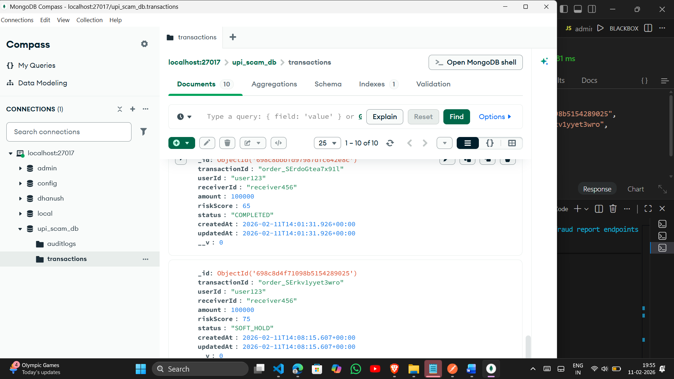

DAY_3

Webhook Controller.js
const Transaction = require('../models/Transaction');

exports.handleWebhook = async (req, res) => {
try {
const event = req.body.event;

if (event === 'payment.captured') {
const payment = req.body.payload?.payment?.entity;

if (!payment) {
return res.status(400).json({ message: "Invalid payload" });
}

const txn = await Transaction.findOne({
transactionId: payment.order_id
});

if (!txn) {
return res.status(404).json({ message: "Transaction not found" });
}

txn.status = "COMPLETED";
await txn.save();
}

res.status(200).json({ message: "Webhook processed" });

} catch (err) {
console.error("Webhook error:", err);
res.status(500).json({ error: err.message });
}
};

adminController.js
const Transaction = require('../models/transaction');
const AuditLog = require('../models/AuditLog');

// Get all transactions
exports.getAllTransactions = async (req, res) => {
try {
const transactions = await Transaction.find().sort({ createdAt: -1 });
res.json(transactions);
} catch (error) {
res.status(500).json({ message: "Server Error" });
}
};

// Get single transaction
exports.getTransactionById = async (req, res) => {
try {
const txn = await Transaction.findById(req.params.id);
if (!txn) return res.status(404).json({ message: "Transaction not found" });

res.json(txn);
} catch (error) {
res.status(500).json({ message: "Server Error" });
}
};

// Flag transaction
exports.flagTransaction = async (req, res) => {
try {
const txn = await Transaction.findById(req.params.id);
if (!txn) return res.status(404).json({ message: "Transaction not found" });

txn.status = "FLAGGED";
await txn.save();

await AuditLog.create({
transactionId: txn._id,
action: "FLAGGED_BY_ADMIN"
});

res.json({ message: "Transaction flagged successfully" });

} catch (error) {
res.status(500).json({ message: "Server Error" });
}
};

// Manually release transaction
exports.releaseTransaction = async (req, res) => {
try {
const txn = await Transaction.findById(req.params.id);
if (!txn) return res.status(404).json({ message: "Transaction not found" });

txn.status = "RELEASED";
await txn.save();

await AuditLog.create({
transactionId: txn._id,
action: "MANUALLY_RELEASED_BY_ADMIN"
});

res.json({ message: "Transaction released successfully" });

} catch (error) {
res.status(500).json({ message: "Server Error" });
}
};

transactionController.js
const Transaction = require('../models/transaction');
const calculateRisk = require('../utils/riskScore');

// Create new transaction
exports.createTransaction = async (req, res) => {
try {
const { userId, amount, razorpayOrderId } = req.body;

const transaction = new Transaction({
userId,
amount,
razorpayOrderId,
status: "PENDING"
});

// Calculate risk immediately
transaction.riskScore = calculateRisk(transaction);

await transaction.save();

res.status(201).json(transaction);

} catch (error) {
res.status(500).json({ message: "Server Error" });
}
};

// Get user's transactions
exports.getUserTransactions = async (req, res) => {
try {
const transactions = await Transaction.find({ userId: req.params.userId })
.sort({ createdAt: -1 });

res.json(transactions);

} catch (error) {
res.status(500).json({ message: "Server Error" });
}
};

webhookRoutes.js
const express = require('express');
const router = express.Router();
const { handleWebhook } = require('../controllers/webhookController');

router.post('/', handleWebhook);

module.exports = router;

adminRoutes.js
const express = require('express');
const router = express.Router();
const adminController = require('../controllers/adminController');

router.get('/transactions', adminController.getAllTransactions);
router.get('/transactions/:id', adminController.getTransactionById);

router.post('/flag/:id', adminController.flagTransaction);
router.post('/release/:id', adminController.releaseTransaction);

module.exports = router;

transactionRoutes.js
const express = require('express');
const router = express.Router();
const transactionController = require('../controllers/transactionController');

router.post('/create', transactionController.createTransaction);
router.get('/user/:userId', transactionController.getUserTransactions);

module.exports = router;

softholdservices.js
const Transaction = require('../models/Transaction');

async function applySoftHold(transactionId) {
const txn = await Transaction.findById(transactionId);
if (!txn) return;

txn.status = 'SOFT_HOLD';
await txn.save();

setTimeout(async () => {
const updatedTxn = await Transaction.findById(transactionId);

if (updatedTxn.status === 'SOFT_HOLD') {
updatedTxn.status = 'RELEASED';
await updatedTxn.save();
console.log("Funds Released");
}
}, 10 * 60 * 1000);
}

module.exports = { applySoftHold };

index.js
require("dotenv").config();

const express = require("express");
const Razorpay = require("razorpay");
const crypto = require("crypto");
const cors = require("cors");
const mongoose = require("mongoose");

const app = express();

/* ------------------ MIDDLEWARE ------------------ */
app.use(express.json());
app.use(cors());

/* ------------------ DATABASE CONNECTION ------------------ */
mongoose
.connect(process.env.MONGO_URI)
.then(() => console.log("MongoDB connected"))
.catch(err => console.error(err));

/* ------------------ RAZORPAY SETUP ------------------ */
const razorpay = new Razorpay({
key_id: process.env.RAZORPAY_KEY_ID,
key_secret: process.env.RAZORPAY_KEY_SECRET
});

/* ------------------ MODELS ------------------ */
const Transaction = require("./models/Transaction");
const AuditLog = require("./models/AuditLog");

/* ------------------ UTILS ------------------ */
const calculateRisk = require("./utils/riskScore");

/* ------------------ ROUTES (DAY 3 STRUCTURE) ------------------ */
app.use("/api/admin", require("./routes/adminRoutes"));
app.use("/api/transactions", require("./routes/transactionRoutes"));
app.use("/webhook", require("./routes/webhookRoutes"));

/* ------------------ HEALTH CHECK ------------------ */
app.get("/", (req, res) => {
res.json({ status: "UPI Scam Containment Backend Running 🚀" });
});

/* ===========================================================
============================================================ */

/* ------------------ CREATE ORDER + CONTAINMENT ------------------ */
app.post("/create-order", async (req, res) => {
try {
const { userId, receiverId, amount } = req.body;

const isNewReceiver = true;
const isOddTime = new Date().getHours() < 6;
const rapidTransfer = false;

const riskScore = calculateRisk(
amount,
isNewReceiver,
isOddTime,
rapidTransfer
);

let status = "COMPLETED";
if (riskScore >= 70) status = "SOFT_HOLD";

const order = await razorpay.orders.create({
amount: amount,
currency: "INR",
receipt: "rcpt_" + Date.now(),
notes: { riskScore }
});

const tx = await Transaction.create({
transactionId: order.id,
userId,
receiverId,
amount,
riskScore,
status
});

const crypto = require("crypto");

const hash = crypto
.createHash("sha256")
.update(tx.transactionId + status + Date.now())
.digest("hex");

await AuditLog.create({
transactionId: tx.transactionId,
action: `Transaction ${status}`,
hash
});

res.json({
message: "Order created",
transactionId: tx._id,
razorpayOrderId: order.id,
riskScore,
status
});

} catch (err) {
console.error("Order Error:", err);
res.status(500).json({ error: err.message });
}

});

/* ------------------ USER CONFIRMS TRANSACTION ------------------ */
app.post("/confirm/:id", async (req, res) => {
const tx = await Transaction.findById(req.params.id);
if (!tx || tx.status !== "SOFT_HOLD") {
return res.status(400).json({ message: "Invalid transaction" });
}

tx.status = "COMPLETED";
await tx.save();

await AuditLog.create({
transactionId: tx.transactionId,
action: "User confirmed transaction"
});

res.json({ message: "Transaction completed successfully" });
});

/* ------------------ USER REPORTS FRAUD ------------------ */
app.post("/report-fraud/:id", async (req, res) => {
const tx = await Transaction.findById(req.params.id);
if (!tx || tx.status !== "SOFT_HOLD") {
return res.status(400).json({ message: "Invalid transaction" });
}

tx.status = "REVERSED";
await tx.save();

await AuditLog.create({
transactionId: tx.transactionId,
action: "Transaction reversed due to fraud"
});

res.json({ message: "Transaction reversed and user protected" });
});

/* ------------------ VERIFY PAYMENT SIGNATURE ------------------ */
app.post("/verify-payment", (req, res) => {
const {
razorpay_payment_id,
razorpay_order_id,
razorpay_signature
} = req.body;

const body = razorpay_order_id + "|" + razorpay_payment_id;

const expectedSignature = crypto
.createHmac("sha256", process.env.RAZORPAY_KEY_SECRET)
.update(body)
.digest("hex");

if (expectedSignature === razorpay_signature) {
res.json({ status: "PAYMENT VERIFIED" });
} else {
res.status(400).json({ status: "INVALID SIGNATURE" });
}
});

/* ------------------ START SERVER ------------------ */
const PORT = process.env.PORT || 8000;

app.listen(PORT, () => {
console.log(`Server running on port ${PORT}`);
});
app.get("/create-order-test", (req, res) => {
res.json({ message: "Route is working" });
});

Transaction.js
const mongoose = require("mongoose");

const transactionSchema = new mongoose.Schema({
transactionId: String,
userId: String,
receiverId: String,
amount: Number,
riskScore: Number,
status: {
type: String,
enum: [
"PENDING",
"COMPLETED",
"SOFT_HOLD",
"RELEASED",
"REVERSED",
"FLAGGED"
],
default: "PENDING"
}
}, { timestamps: true });

module.exports =
mongoose.models.Transaction ||
mongoose.model("Transaction", transactionSchema);

riskscore.js
function calculateRisk(amount, isNewReceiver, isOddTime, rapidTransfer) {
let score = 0;

if (amount > 50000) score += 50; // High amount
if (isNewReceiver) score += 25; // Unknown receiver
if (isOddTime) score += 15; // Night transaction
if (rapidTransfer) score += 20; // Multiple quick txns

return Math.min(score, 100);
}

module.exports = calculateRisk;

auditlog.js
const mongoose = require("mongoose");

const auditSchema = new mongoose.Schema({
transactionId: String,
action: String,
timestamp: { type: Date, default: Date.now },
hash: String
});

module.exports =
mongoose.models.AuditLog ||
mongoose.model("AuditLog", auditSchema);

auditlog.js
const mongoose = require("mongoose");

const auditSchema = new mongoose.Schema({
transactionId: String,
action: String,
timestamp: { type: Date, default: Date.now },
hash: String
});

module.exports =
mongoose.models.AuditLog ||
mongoose.model("AuditLog", auditSchema);

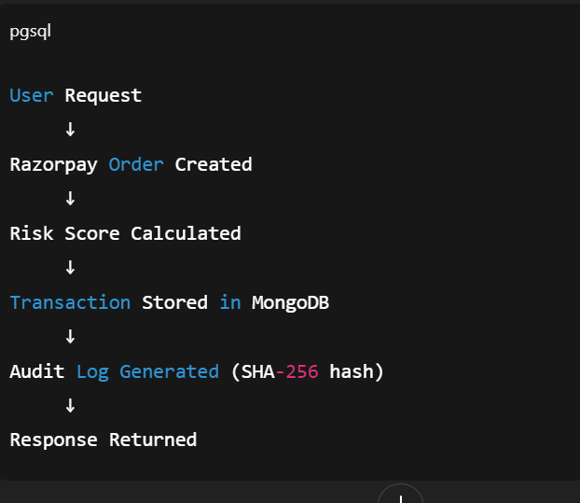

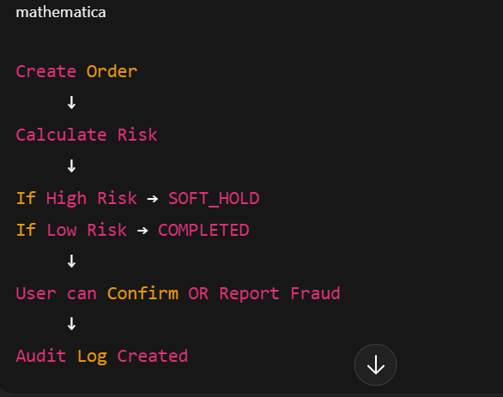

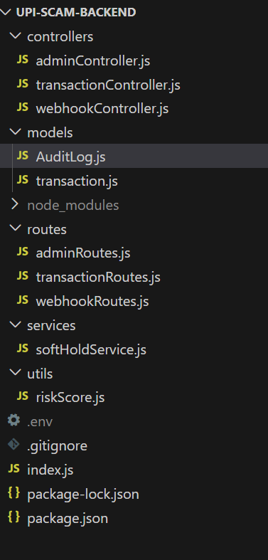

Perfect 🔥
Here is a clean, professional Day-3 Summary of your UPI Scam Containment Protocol work.
You can use this for:
- GitHub commit
- README update
- Internship log
- Viva explanation
- LinkedIn post

🛡 UPI Scam Containment Protocol
✅ Day-3 Progress Summary

🎯 Objective of Day-3
Implement core fraud containment logic with structured backend architecture and secure audit logging.

🔧 Backend Refactoring (Major Upgrade)
🔹 1️⃣ Clean Project Architecture
Refactored project into professional structure:
models/
utils/
controllers/
routes/
index.js
Separated:
- Routes → Endpoint mapping
- Controllers → Business logic
- Models → Database schema
- Utils → Risk scoring engine
This improves scalability and maintainability.

🧠 2️⃣ Risk Scoring Engine
Implemented fraud scoring logic based on:
- High transaction amount
- New receiver
- Odd-time transaction
- Rapid transfer behavior
riskScore = calculateRisk(...)
Decision logic:
If riskScore ≥ 70 → SOFT_HOLD
Else → COMPLETED

🛑 3️⃣ Soft Hold Containment Logic
High-risk transactions are placed in:
SOFT_HOLD
Low-risk transactions:
COMPLETED
This simulates a fraud cooling-off window.

💳 4️⃣ Razorpay Order Integration
Successfully integrated:
- Razorpay order creation
- Order ID stored in MongoDB
- Response returned with transaction details

🔄 5️⃣ Fraud Control APIs
Implemented:
➤ POST /create-order
Creates transaction + calculates risk.
➤ POST /confirm/:id
User confirms soft-hold transaction.
➤ POST /report-fraud/:id
User reverses suspicious transaction.

🔐 6️⃣ Secure Audit Logging
Implemented tamper-resistant audit logs using:
crypto.createHash("sha256")
Stored:
- transactionId
- action
- timestamp
- hash
Ensures transaction history integrity.

🛠 7️⃣ Major Debugging Completed
Resolved:
- ❌ Mongoose OverwriteModelError
- ❌ next is not a function
- ❌ Middleware misconfiguration
- ❌ Webhook controller structure issue
- ❌ Model export duplication
System is now stable.

📊 Current System Flow
User initiates payment
↓
Razorpay order created
↓
Risk score calculated
↓
If High Risk → SOFT_HOLD
If Low Risk → COMPLETED
↓
User can Confirm or Report Fraud
↓
Audit log generated

📈 Project Status After Day-3
Component | Status
Risk Engine | ✅ Working
Soft Hold Trigger | ✅ Working
Fraud Reversal | ✅ Working
Audit Logging | ✅ Working
Razorpay Integration | ✅ Working
Database Persistence | ✅ Working
Modular Architecture | ✅ Implemented

🧠 Progress Level
You are now at approximately:
45–50% completion of a production-style containment system
Core logic is complete.
Next phase focuses on automation & security hardening.

🚀 Day-4 Planned Work
- Automatic release after soft-hold delay
- Admin override APIs
- Security middleware (rate limiting, helmet)
- Webhook signature verification
- Advanced fraud rules

If you want, I can now give you:
- 📄 Professional GitHub README
- 💼 LinkedIn project post
- 🎓 Viva explanation script
- 📊 Architecture explanation for presentation
Tell me what you need next 🔥

Day-4

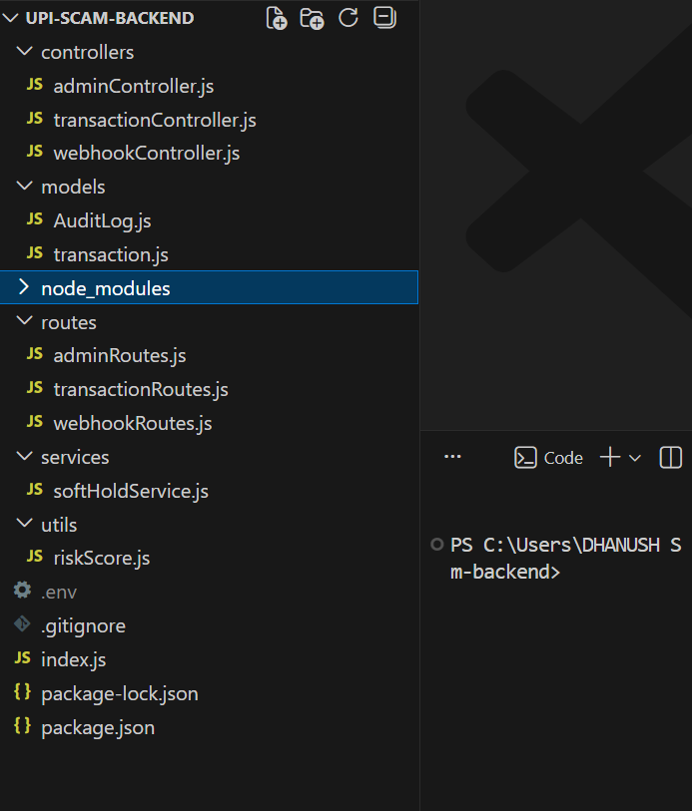

Admincontroller.js
const Transaction = require('../models/transaction');
const AuditLog = require('../models/AuditLog');

// Get all transactions
exports.getAllTransactions = async (req, res) => {
try {
const transactions = await Transaction.find().sort({ createdAt: -1 });
res.json(transactions);
} catch (error) {
res.status(500).json({ message: "Server Error" });
}
};

// Get single transaction
exports.getTransactionById = async (req, res) => {
try {
const txn = await Transaction.findById(req.params.id);
if (!txn) return res.status(404).json({ message: "Transaction not found" });

res.json(txn);
} catch (error) {
res.status(500).json({ message: "Server Error" });
}
};

// Flag transaction
exports.flagTransaction = async (req, res) => {
try {
const txn = await Transaction.findById(req.params.id);
if (!txn) return res.status(404).json({ message: "Transaction not found" });

txn.status = "FLAGGED";
await txn.save();

await AuditLog.create({
transactionId: txn._id,
action: "FLAGGED_BY_ADMIN"
});

res.json({ message: "Transaction flagged successfully" });

} catch (error) {
res.status(500).json({ message: "Server Error" });
}
};

// Manually release transaction
exports.releaseTransaction = async (req, res) => {
try {
const txn = await Transaction.findById(req.params.id);
if (!txn) return res.status(404).json({ message: "Transaction not found" });

txn.status = "RELEASED";
await txn.save();

await AuditLog.create({
transactionId: txn._id,
action: "MANUALLY_RELEASED_BY_ADMIN"
});

res.json({ message: "Transaction released successfully" });

} catch (error) {
res.status(500).json({ message: "Server Error" });
}
};

Transactioncontroller.js
const crypto = require("crypto");
const Transaction = require("../models/Transaction");
const AuditLog = require("../models/AuditLog");
const calculateRisk = require("../utils/riskScore");
const { scheduleAutoRelease } = require("../services/softHoldService");

/* ================= CREATE TRANSACTION ================= */
exports.createTransaction = async (req, res) => {
try {
const { userId, receiverId, amount } = req.body;

const isNewReceiver = true;
const isOddTime = new Date().getHours() < 6;
const rapidTransfer = false;

const riskScore = calculateRisk(
amount,
isNewReceiver,
isOddTime,
rapidTransfer
);

let status = "COMPLETED";
if (riskScore >= 70) status = "SOFT_HOLD";

const transaction = await Transaction.create({
userId,
receiverId,
amount,
riskScore,
status
});

if (status === "SOFT_HOLD") {
scheduleAutoRelease(transaction._id);
}

const hash = crypto
.createHash("sha256")
.update(transaction._id + status + Date.now())
.digest("hex");

await AuditLog.create({
transactionId: transaction._id,
action: `Transaction ${status}`,
hash
});

res.status(201).json(transaction);

} catch (error) {
console.error(error);
res.status(500).json({ message: "Server Error" });
}
};

/* ================= CONFIRM ================= */
exports.confirmTransaction = async (req, res) => {
try {
const tx = await Transaction.findById(req.params.id);

if (!tx) return res.status(404).json({ message: "Not found" });

if (tx.status !== "SOFT_HOLD") {
return res.status(400).json({
message: "Transaction already processed"
});
}

tx.status = "COMPLETED";
await tx.save();

res.json({ message: "Transaction confirmed" });

} catch (error) {
res.status(500).json({ message: "Server Error" });
}
};

/* ================= REPORT FRAUD ================= */
exports.reportFraud = async (req, res) => {
try {
const tx = await Transaction.findById(req.params.id);

if (!tx) return res.status(404).json({ message: "Not found" });

if (tx.status !== "SOFT_HOLD") {
return res.status(400).json({
message: "Cannot reverse this transaction"
});
}

tx.status = "REVERSED";
await tx.save();

res.json({ message: "Transaction reversed" });

} catch (error) {
res.status(500).json({ message: "Server Error" });
}
};

Webhookcontroller.js
const Transaction = require('../models/Transaction');

exports.handleWebhook = async (req, res) => {
try {
const event = req.body.event;

if (event === 'payment.captured') {
const payment = req.body.payload?.payment?.entity;

if (!payment) {
return res.status(400).json({ message: "Invalid payload" });
}

const txn = await Transaction.findOne({
transactionId: payment.order_id
});

if (!txn) {
return res.status(404).json({ message: "Transaction not found" });
}

txn.status = "COMPLETED";
await txn.save();
}

res.status(200).json({ message: "Webhook processed" });

} catch (err) {
console.error("Webhook error:", err);
res.status(500).json({ error: err.message });
}
};

Auditlog.js
const mongoose = require("mongoose");

const auditSchema = new mongoose.Schema({
transactionId: String,
action: String,
timestamp: { type: Date, default: Date.now },
hash: String
});

module.exports =
mongoose.models.AuditLog ||
mongoose.model("AuditLog", auditSchema);

transaction.js
const mongoose = require("mongoose");

const transactionSchema = new mongoose.Schema({
userId: String,
receiverId: String,
amount: Number,
riskScore: Number,
status: {
type: String,
enum: ["COMPLETED", "SOFT_HOLD", "REVERSED"],
default: "COMPLETED"
}
}, { timestamps: true });

module.exports =
mongoose.models.Transaction ||
mongoose.model("Transaction", transactionSchema);

adminroute.js
const express = require('express');
const router = express.Router();
const adminController = require('../controllers/adminController');

router.get('/transactions', adminController.getAllTransactions);
router.get('/transactions/:id', adminController.getTransactionById);

router.post('/flag/:id', adminController.flagTransaction);
router.post('/release/:id', adminController.releaseTransaction);

module.exports = router;

transactionroute.js
const express = require("express");
const router = express.Router();
const transactionController = require("../controllers/transactionController");

router.post("/create", transactionController.createTransaction);
router.post("/confirm/:id", transactionController.confirmTransaction);
router.post("/report/:id", transactionController.reportFraud);

module.exports = router;

webhookroutes.js
const express = require('express');
const router = express.Router();
const { handleWebhook } = require('../controllers/webhookController');

router.post('/', handleWebhook);

module.exports = router;

softholdservices.js
const Transaction = require("../models/Transaction");
const AuditLog = require("../models/AuditLog");
const crypto = require("crypto");

exports.scheduleAutoRelease = (transactionId) => {
setTimeout(async () => {
try {
const tx = await Transaction.findById(transactionId);

if (tx && tx.status === "SOFT_HOLD") {
tx.status = "COMPLETED";
await tx.save();

const hash = crypto
.createHash("sha256")
.update(tx._id + "AUTO_RELEASE" + Date.now())
.digest("hex");

await AuditLog.create({
transactionId: tx._id,
action: "Auto released after soft hold",
hash
});

console.log("Auto Released:", tx._id);
}

} catch (err) {
console.error("Auto release error:", err);
}
}, 30 * 1000); // ⚠️ 30 sec for testing (change to 10*60*1000 later)
};

Riskscore.js
function calculateRisk(amount, isNewReceiver, isOddTime, rapidTransfer) {
let score = 0;

if (amount > 50000) score += 50;
if (isNewReceiver) score += 25;
if (isOddTime) score += 15;
if (rapidTransfer) score += 20;

return Math.min(score, 100);
}

module.exports = calculateRisk;

index.js
require("dotenv").config();

const express = require("express");
const Razorpay = require("razorpay");
const crypto = require("crypto");
const cors = require("cors");
const mongoose = require("mongoose");
const helmet = require("helmet");
const rateLimit = require("express-rate-limit");

const app = express();

/* ------------------ MIDDLEWARE ------------------ */
app.use(express.json());
app.use(cors());
app.use(helmet());

const limiter = rateLimit({
windowMs: 15 * 60 * 1000,
max: 100
});

app.use(limiter);

/* ------------------ DATABASE CONNECTION ------------------ */
mongoose
.connect(process.env.MONGO_URI)
.then(() => console.log("MongoDB connected"))
.catch(err => console.error(err));

/* ------------------ RAZORPAY SETUP ------------------ */
const razorpay = new Razorpay({
key_id: process.env.RAZORPAY_KEY_ID,
key_secret: process.env.RAZORPAY_KEY_SECRET
});

/* ------------------ ROUTES ------------------ */
app.use("/api/transactions", require("./routes/transactionRoutes"));
app.use("/api/admin", require("./routes/adminRoutes"));
app.use("/webhook", require("./routes/webhookRoutes"));

/* ------------------ HEALTH CHECK ------------------ */
app.get("/", (req, res) => {
res.json({ status: "UPI Scam Containment Backend Running 🚀" });
});

/* ------------------ VERIFY PAYMENT SIGNATURE ------------------ */
app.post("/verify-payment", (req, res) => {
const {
razorpay_payment_id,
razorpay_order_id,
razorpay_signature
} = req.body;

const body = razorpay_order_id + "|" + razorpay_payment_id;

const expectedSignature = crypto
.createHmac("sha256", process.env.RAZORPAY_KEY_SECRET)
.update(body)
.digest("hex");

if (expectedSignature === razorpay_signature) {
res.json({ status: "PAYMENT VERIFIED" });
} else {
res.status(400).json({ status: "INVALID SIGNATURE" });
}
});

/* ------------------ START SERVER ------------------ */
const PORT = process.env.PORT || 8000;

app.listen(PORT, () => {
console.log(`Server running on port ${PORT}`);
});

DAY-5

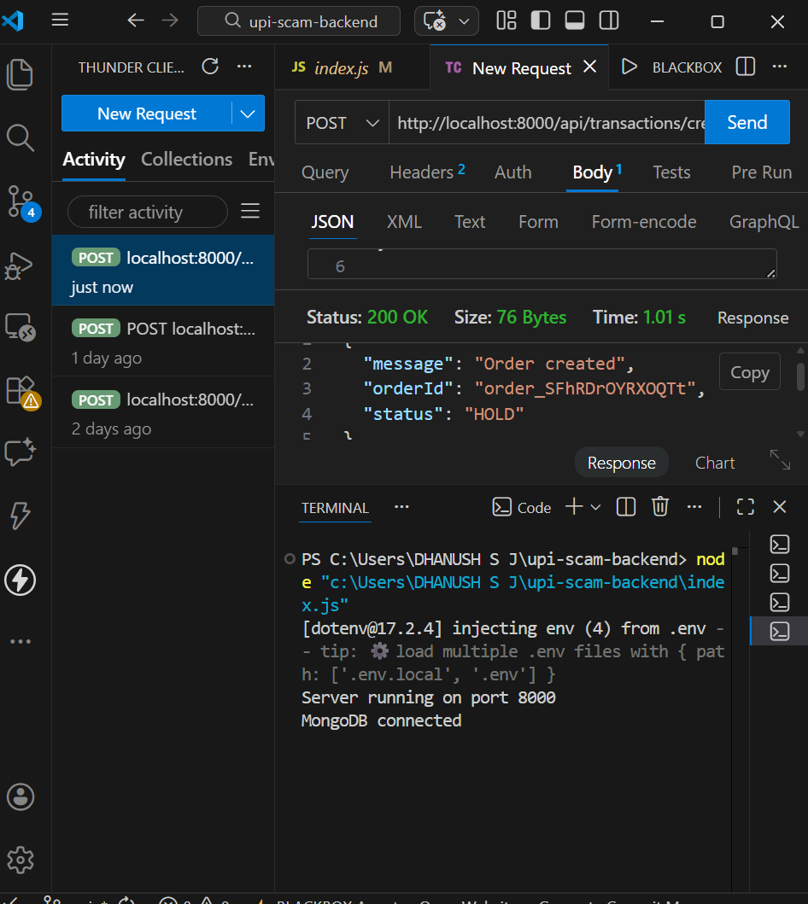

Tc
const Razorpay = require("razorpay");
const Transaction = require("../models/transaction");
const calculateRisk = require("../utils/riskScore");

const razorpay = new Razorpay({
key_id: process.env.RAZORPAY_KEY_ID,
key_secret: process.env.RAZORPAY_KEY_SECRET
});

exports.createTransaction = async (req, res) => {
res.json({ message: "create working" });
};

exports.savePayment = async (req, res) => {
res.json({ message: "save working" });
};

exports.capturePayment = async (req, res) => {
res.json({ message: "capture working" });
};

exports.refundPayment = async (req, res) => {
res.json({ message: "refund working" });
};

Day 5 code

Admin controller.js
const Transaction = require('../models/transaction');
const AuditLog = require('../models/AuditLog');

// Get all transactions
exports.getAllTransactions = async (req, res) => {
try {
const transactions = await Transaction.find().sort({ createdAt: -1 });
res.json(transactions);
} catch (error) {
res.status(500).json({ message: "Server Error" });
}
};

// Get single transaction
exports.getTransactionById = async (req, res) => {
try {
const txn = await Transaction.findById(req.params.id);
if (!txn) return res.status(404).json({ message: "Transaction not found" });

res.json(txn);
} catch (error) {
res.status(500).json({ message: "Server Error" });
}
};

// Flag transaction
exports.flagTransaction = async (req, res) => {
try {
const txn = await Transaction.findById(req.params.id);
if (!txn) return res.status(404).json({ message: "Transaction not found" });

txn.status = "FLAGGED";
await txn.save();

await AuditLog.create({
transactionId: txn._id,
action: "FLAGGED_BY_ADMIN"
});

res.json({ message: "Transaction flagged successfully" });

} catch (error) {
res.status(500).json({ message: "Server Error" });
}
};

// Manually release transaction
exports.releaseTransaction = async (req, res) => {
try {
const txn = await Transaction.findById(req.params.id);
if (!txn) return res.status(404).json({ message: "Transaction not found" });

txn.status = "RELEASED";
await txn.save();

await AuditLog.create({
transactionId: txn._id,
action: "MANUALLY_RELEASED_BY_ADMIN"
});

res.json({ message: "Transaction released successfully" });

} catch (error) {
res.status(500).json({ message: "Server Error" });
}
};

Transaction controller.js
const Razorpay = require("razorpay");
const Transaction = require("../models/transaction");
const calculateRisk = require("../utils/riskScore");

const razorpay = new Razorpay({
key_id: process.env.RAZORPAY_KEY_ID,
key_secret: process.env.RAZORPAY_KEY_SECRET
});

exports.createTransaction = async (req, res) => {
try {
const { userId, receiverId, amount } = req.body;

const isNewReceiver = true;
const isOddTime = new Date().getHours() < 6;
const rapidTransfer = false;

const riskScore = calculateRisk(
amount,
isNewReceiver,
isOddTime,
rapidTransfer
);

let status = "HOLD";
console.log("FORCE HOLD ACTIVE");

const order = await razorpay.orders.create({
amount: amount * 100,
currency: "INR"
});

const transaction = await Transaction.create({
userId,
receiverId,
amount,
riskScore,
status,
razorpayOrderId: order.id
});
console.log("Inserted transaction:", transaction);

res.json({
message: "Order created",
orderId: order.id,
transactionId: transaction._id,
status
});

} catch (error) {
console.error(error);
res.status(500).json({ message: "Order creation failed" });
}
};

exports.savePayment = async (req, res) => {
try {
const { orderId, paymentId } = req.body;

const tx = await Transaction.findOne({ razorpayOrderId: orderId });

if (!tx) {
return res.status(404).json({ message: "Transaction not found" });
}

tx.razorpayPaymentId = paymentId;
await tx.save();

// 🔥 ADD THIS LINE HERE
console.log("Updated TX:", tx);

res.json({ message: "Payment recorded successfully" });

} catch (error) {
console.error(error);
res.status(500).json({ message: "Save payment failed" });
}
};

exports.capturePayment = async (req, res) => {
try {
const tx = await Transaction.findById(req.params.id);

if (!tx || !tx.razorpayPaymentId) {
return res.status(400).json({ message: "Invalid transaction" });
}

// Call Razorpay capture API
await razorpay.payments.capture(
tx.razorpayPaymentId,
tx.amount * 100
);

tx.status = "COMPLETED";
await tx.save();

res.json({ message: "Payment captured successfully" });

} catch (err) {
console.error(err);
res.status(500).json({ message: "Capture failed" });
}
};

exports.refundPayment = async (req, res) => {
res.json({ message: "refund working" });
};

Webhookcontroller.js
const Transaction = require('../models/Transaction');

exports.handleWebhook = async (req, res) => {
try {
const event = req.body.event;

if (event === 'payment.captured') {
const payment = req.body.payload?.payment?.entity;

if (!payment) {
return res.status(400).json({ message: "Invalid payload" });
}

const txn = await Transaction.findOne({
transactionId: payment.order_id
});

if (!txn) {
return res.status(404).json({ message: "Transaction not found" });
}

txn.status = "COMPLETED";
await txn.save();
}

res.status(200).json({ message: "Webhook processed" });

} catch (err) {
console.error("Webhook error:", err);
res.status(500).json({ error: err.message });
}
};

Auditlog.js
const mongoose = require("mongoose");

const auditSchema = new mongoose.Schema({
transactionId: String,
action: String,
timestamp: { type: Date, default: Date.now },
hash: String
});

module.exports =
mongoose.models.AuditLog ||
mongoose.model("AuditLog", auditSchema);

transaction.js
const mongoose = require("mongoose");

const transactionSchema = new mongoose.Schema({
userId: String,
receiverId: String,
amount: Number,
riskScore: Number,
status: {
type: String,
enum: ["HOLD", "COMPLETED", "REVERSED"],
default: "HOLD"
},
razorpayOrderId: String,
razorpayPaymentId: String
}, { timestamps: true });

module.exports = mongoose.model("Transaction", transactionSchema);

adminroute.js
const express = require('express');
const router = express.Router();
const adminController = require('../controllers/adminController');

router.get('/transactions', adminController.getAllTransactions);
router.get('/transactions/:id', adminController.getTransactionById);

router.post('/flag/:id', adminController.flagTransaction);
router.post('/release/:id', adminController.releaseTransaction);

module.exports = router;

transactionroute.js
const express = require("express");
const router = express.Router();

const transactionController = require("../controllers/transactionController");

router.post("/create", transactionController.createTransaction);
router.post("/save-payment", transactionController.savePayment);
router.post("/capture/:id", transactionController.capturePayment);
router.post("/refund/:id", transactionController.refundPayment);

module.exports = router;

webhookroutes.js
const express = require('express');
const router = express.Router();
const { handleWebhook } = require('../controllers/webhookController');

router.post('/', handleWebhook);

module.exports = router;

softholdservices.js
const Transaction = require("../models/Transaction");
const AuditLog = require("../models/AuditLog");
const crypto = require("crypto");

exports.scheduleAutoRelease = (transactionId) => {
setTimeout(async () => {
try {
const tx = await Transaction.findById(transactionId);

if (tx && tx.status === "SOFT_HOLD") {
tx.status = "COMPLETED";
await tx.save();

const hash = crypto
.createHash("sha256")
.update(tx._id + "AUTO_RELEASE" + Date.now())
.digest("hex");

await AuditLog.create({
transactionId: tx._id,
action: "Auto released after soft hold",
hash
});

console.log("Auto Released:", tx._id);
}

} catch (err) {
console.error("Auto release error:", err);
}
}, 30 * 1000); // ⚠️ 30 sec for testing (change to 10*60*1000 later)
};

Riskscore.js
function calculateRisk(amount, isNewReceiver, isOddTime, rapidTransfer) {
let score = 0;

if (amount > 50000) score += 50;
if (isNewReceiver) score += 25;
if (isOddTime) score += 15;
if (rapidTransfer) score += 20;

return Math.min(score, 100);
}

module.exports = calculateRisk;

test.html
<!DOCTYPE html>
<html>
<head>
<title>Razorpay Test</title>
<script src="https://checkout.razorpay.com/v1/checkout.js"></script>
</head>
<body>

<h2>UPI Scam Containment - Test Payment</h2>

<button onclick="payNow()">Pay Now</button>

<script>
function payNow() {

var options = {
key: "rzp_test_SDtnqeeFeS0ztb", // 🔴 Replace with your real test key
order_id: "order_SFuuvGr9M7rAws", // 🔴 Replace with fresh order ID

name: "Fraud Containment Test",
description: "Test Payment",

handler: function (response){
alert("Payment ID: " + response.razorpay_payment_id);
alert("Order ID: " + response.razorpay_order_id);
},

modal: {
ondismiss: function(){
alert("Payment popup closed");
}
}
};

var rzp1 = new Razorpay(options);
rzp1.open();
}
</script>

</body>
</html>

DAY_6

: pay_SFvhyHORhzAgcz

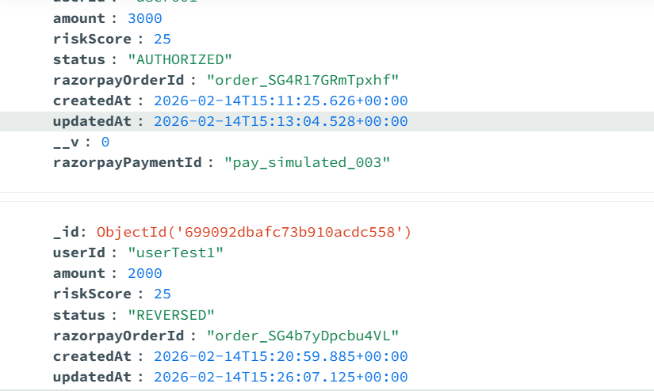

i want a safehold containment window in that money hold if sender sends the mmoney is stored in that place id dont go receiver automatically once sender detects receiver fraud it automatically caputre the money it wont allow to go to receiver then sender can retrieve it back so this is my idea i need to create application for that and fraud detection need to predict earlier before the transaction like that i need

admin.html
<!DOCTYPE html>
<html>
<head>
<title>Admin Dashboard</title>
<script src="https://cdn.jsdelivr.net/npm/chart.js"></script>
</head>
<body>

<h1>Admin Dashboard</h1>

<button onclick="loadOverview()">Load Overview</button>
<button onclick="loadRisk()">Risk Distribution</button>
<button onclick="loadDaily()">Daily Transactions</button>
<button onclick="loadFraud()">Fraud Transactions</button>

<h2>Blacklist Receiver</h2>
<input type="text" id="receiverId" placeholder="Receiver ID">
<input type="text" id="reason" placeholder="Reason">
<button onclick="blacklist()">Blacklist</button>

<h2>Overview Chart</h2>
<canvas id="overviewChart" width="400" height="200"></canvas>

<h2>Risk Distribution Chart</h2>
<canvas id="riskChart" width="400" height="200"></canvas>

<h2>Daily Transactions Chart</h2>
<canvas id="dailyChart" width="400" height="200"></canvas>

<h2>Fraud Transactions</h2>
<pre id="fraudOutput"></pre>

<script>
let overviewChart, riskChart, dailyChart;

// =======================
// Overview Chart
// =======================
async function loadOverview() {
const res = await fetch("/api/analytics/overview");
const data = await res.json();

const ctx = document.getElementById('overviewChart').getContext('2d');

if (overviewChart) overviewChart.destroy();

overviewChart = new Chart(ctx, {
type: 'bar',
data: {
labels: ['Completed', 'Hold', 'Reversed'],
datasets: [{
label: 'Transactions',
data: [data.completed, data.hold, data.reversed]
}]
}
});
}

// =======================
// Risk Distribution Chart
// =======================
async function loadRisk() {
const res = await fetch("/api/analytics/risk-distribution");
const data = await res.json();

const ctx = document.getElementById('riskChart').getContext('2d');

if (riskChart) riskChart.destroy();

riskChart = new Chart(ctx, {
type: 'pie',
data: {
labels: ['Low Risk', 'Medium Risk', 'High Risk'],
datasets: [{
data: [data.low, data.medium, data.high]
}]
}
});
}

// =======================
// Daily Transactions Chart
// =======================
async function loadDaily() {
const res = await fetch("/api/analytics/daily-transactions");
const data = await res.json();

const labels = data.map(d => d._id);
const counts = data.map(d => d.count);

const ctx = document.getElementById('dailyChart').getContext('2d');

if (dailyChart) dailyChart.destroy();

dailyChart = new Chart(ctx, {
type: 'line',
data: {
labels: labels,
datasets: [{
label: 'Transactions per Day',
data: counts
}]
}
});
}

// =======================
// Fraud Transactions
// =======================
async function loadFraud() {
const res = await fetch("/api/admin/fraud");
const data = await res.json();
document.getElementById("fraudOutput").innerText =
JSON.stringify(data, null, 2);
}

// =======================
// Blacklist Receiver
// =======================
async function blacklist() {
const receiverId = document.getElementById("receiverId").value;
const reason = document.getElementById("reason").value;

await fetch("/api/admin/blacklist", {
method: "POST",
headers: {"Content-Type":"application/json"},
body: JSON.stringify({ receiverId, reason })
});

alert("Receiver blacklisted");
}
</script>

</body>
</html>-

Index.html
<!DOCTYPE html> <html> <head> <title>UPI Fraud Detection Payment</title> <script src="https://checkout.razorpay.com/v1/checkout.js"></script> </head> <body> <h2>UPI Payment Test</h2> <input type="text" id="userId" placeholder="User ID" value="user1"><br><br> <input type="text" id="receiverId" placeholder="Receiver ID" value="receiver1"><br><br> <input type="number" id="amount" placeholder="Amount" value="15000"><br><br> <button onclick="startPayment()">Pay Now</button> <h3 id="status">Status: Not Started</h3> <button id="confirmBtn" onclick="confirmPayment()">Confirm Payment</button> <button id="cancelBtn" onclick="cancelPayment()">Cancel Payment</button> <script> let transactionId = null; let orderIdGlobal = null; let statusInterval = null; // =============================== // START PAYMENT // =============================== async function startPayment() { try { const userId = document.getElementById("userId").value; const receiverId = document.getElementById("receiverId").value; const amount = document.getElementById("amount").value; document.getElementById("status").innerText = "Creating transaction..."; const res = await fetch("http://localhost:8000/api/transaction/create", { method: "POST", headers: { "Content-Type": "application/json" }, body: JSON.stringify({ userId, receiverId, amount }) }); const data = await res.json(); console.log("Create Transaction:", data); transactionId = data.transactionId; orderIdGlobal = data.orderId; document.getElementById("status").innerText = "Transaction Created | Risk Score: " + data.riskScore; const options = { key: "rzp_test_SDtnqeeFeS0ztb", amount: amount * 100, currency: "INR", order_id: orderIdGlobal, handler: async function (response) { document.getElementById("status").innerText = "Payment Authorized. Processing..."; const saveRes = await fetch("http://localhost:8000/api/transaction/save-payment", { method: "POST", headers: { "Content-Type": "application/json" }, body: JSON.stringify({ paymentId: response.razorpay_payment_id }) }); const saveData = await saveRes.json(); console.log("Save Payment Response:", saveData); checkStatus(); startStatusPolling(); } }; const rzp = new Razorpay(options); rzp.open(); } catch (error) { console.error(error); document.getElementById("status").innerText = "Error starting payment"; } } // =============================== // STATUS POLLING // =============================== function startStatusPolling() { if (statusInterval) clearInterval(statusInterval); statusInterval = setInterval(async () => { await checkStatus(); }, 3000); } // =============================== // CHECK STATUS // =============================== async function checkStatus() { if (!transactionId) return; const res = await fetch(`http://localhost:8000/api/transaction/status/${transactionId}`); const data = await res.json(); console.log("Status:", data); document.getElementById("status").innerText = "Status: " + data.status + " | Risk Score: " + data.riskScore; // Enable buttons only when HOLD if (data.status === "HOLD") { document.getElementById("confirmBtn").disabled = false; document.getElementById("cancelBtn").disabled = false; } else { document.getElementById("confirmBtn").disabled = true; document.getElementById("cancelBtn").disabled = true; } if (data.status === "COMPLETED" || data.status === "REVERSED") { clearInterval(statusInterval); } } // =============================== // CONFIRM PAYMENT // =============================== async function confirmPayment() { if (!transactionId) return; const res = await fetch("http://localhost:8000/api/transaction/confirm", { method: "POST", headers: {"Content-Type":"application/json"}, body: JSON.stringify({ transactionId }) }); const data = await res.json(); console.log(data); startStatusPolling(); } // =============================== // CANCEL PAYMENT // =============================== async function cancelPayment() { if (!transactionId) return; const res = await fetch("http://localhost:8000/api/transaction/cancel", { method: "POST", headers: {"Content-Type":"application/json"}, body: JSON.stringify({ transactionId }) }); const data = await res.json(); console.log(data); startStatusPolling(); } </script> </body> </html>

Admin Dashboard http://localhost:8000/admin.html
UPI Fraud Detection Payment http://localhost:8000/

